## Skill-React

React Hands-on Lab: StudentApp

# Code:

## Terminal Instructions:

**# 1. Create a new React project named studentapp**

**npx create-react-app studentapp**

**# 2. Navigate into the project directory**

**cd studentapp**

**# 3. Open the project in Visual Studio Code**

**code .**

# Codes:

## Home.js:

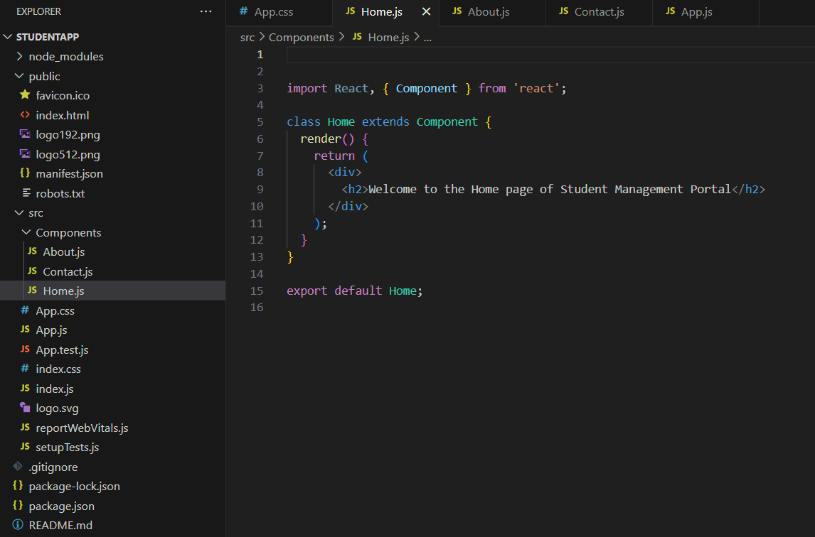

## About.js:

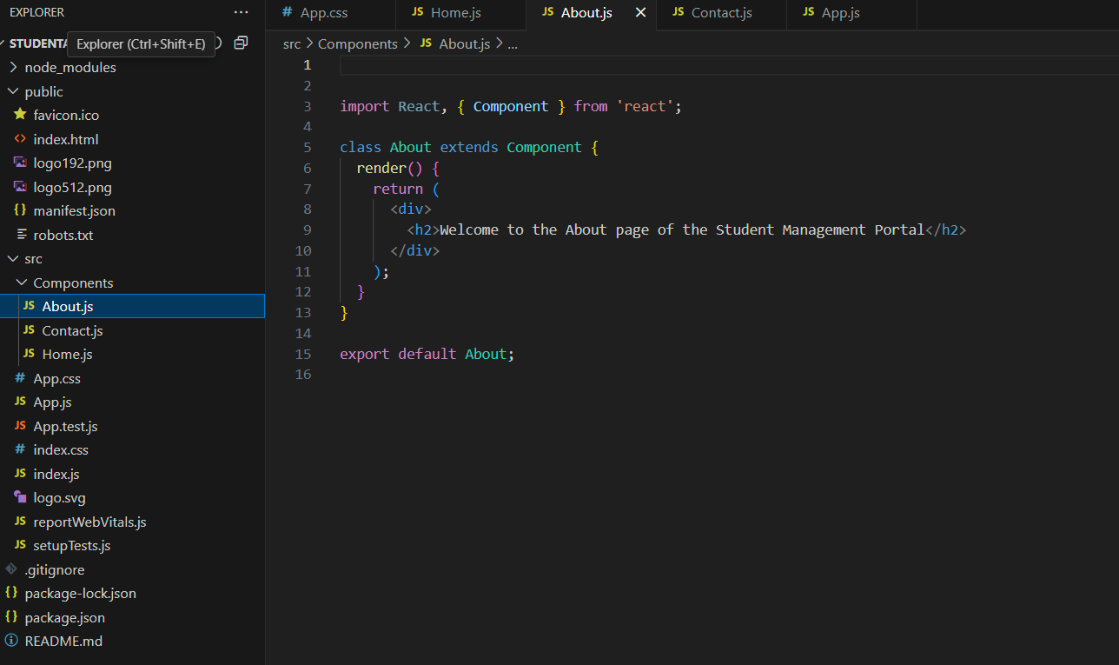

## Contact.js:

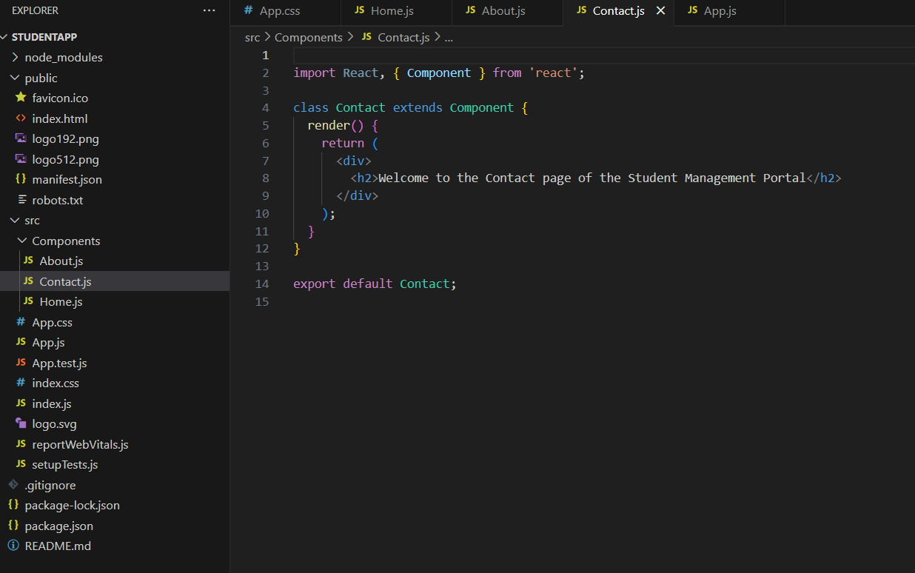

## App.js:

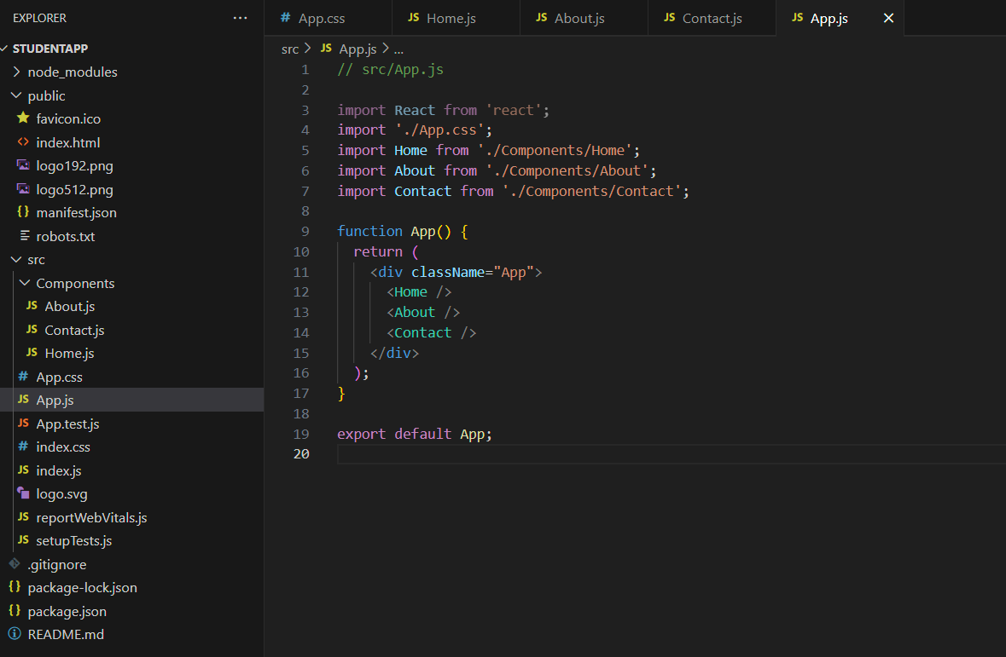

# Output:

